

D. Y. PATIL COLLEGE OF ENGINEERING AND TECHNOLOGY KASABA BAWADA, KOLHAPUR

DEPARTMENT OF COMPUTER SCIENCE AND ENGINEERING

**MINI PROJECT REPORT**

**SYB-CSE, AOOC, May 2025**

**BOAT TICKET SALES SYSTEM( FOR LOCAL LAKE)**

|  |  |  |  |  |  |
| --- | --- | --- | --- | --- | --- |
| **Batch** | **Group No.** | **Juno ID** | **Roll no.** | **Student Name** | **Sign** |
| **S6** | **G32** | EN23141498 | **131** | **Ganesh Bhimrao Kamble** |  |
| EN23247853 | **133** | **Sanchit Satapa Patil** |  |
| EN23189181 | **129** | **Siddhi Ajit Patil** |  |
| EN23223590 | **126** | **Diya Jayesh Patel** |  |
|  |  |  |  |

Course Faculty:Miss.Shobha Patil

**INTRODUCTION**

The **Boat Ticket Sales System (for Local Lake)** is a Java-based mini project designed to automate and simplify the process of booking and managing boat rides for a local lake. In many tourist and recreational areas, traditional paper-based ticketing methods are inefficient, prone to human error, and lack real-time updates. This project addresses those challenges by developing a structured, object-oriented application that brings efficiency, accuracy, and ease of use to boat ticket sales.

The system leverages core Java programming concepts. It uses classes like Boat, Ticket, Schedule, and Customer to represent the essential entities involved in the system. It also incorporates interfaces such as Bookable and Cancelable to define behaviors related to ticket operations. The use of custom exception handling through Overbooking Exception ensures system stability and user feedback in case of booking beyond capacity.

To manage and preserve important data, the system applies file I/O operations for storing boat schedules and sales logs. A user-friendly Graphical User Interface (GUI) is provided to facilitate intuitive ticket booking and schedule viewing. Additionally, the project is organized using Java packages like ticketing, operations, and reporting for better modularity, maintainability, and separation of concerns.

This project not only strengthens understanding of Java programming principles but also provides a practical solution for small-scale water transport systems to digitize and optimize their operations.

**PROBLEM STATEMENT**

The Boat Ticket Sales System aims to streamline the booking and management of boat tickets for a local lake. It provides a user-friendly interface for customers to book and cancel tickets, ensures proper schedule handling, and maintains sales and schedule data through file I/O, while utilizing object-oriented concepts like classes, interfaces, exception handling, and packages for modular design.

**SYSTEM ARCHITECTURE**

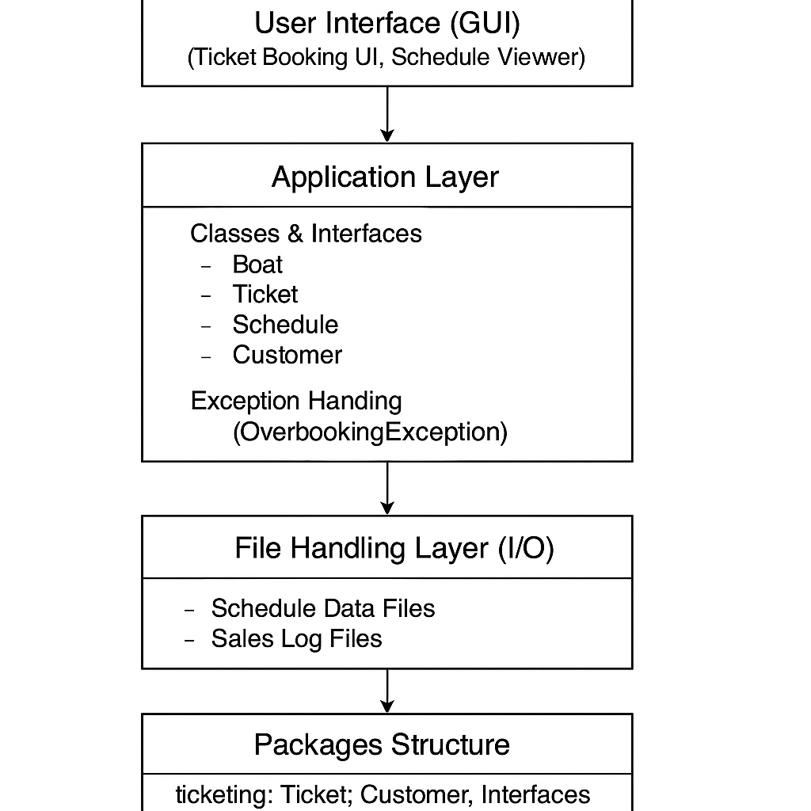

**CLASS DIAGRAM**

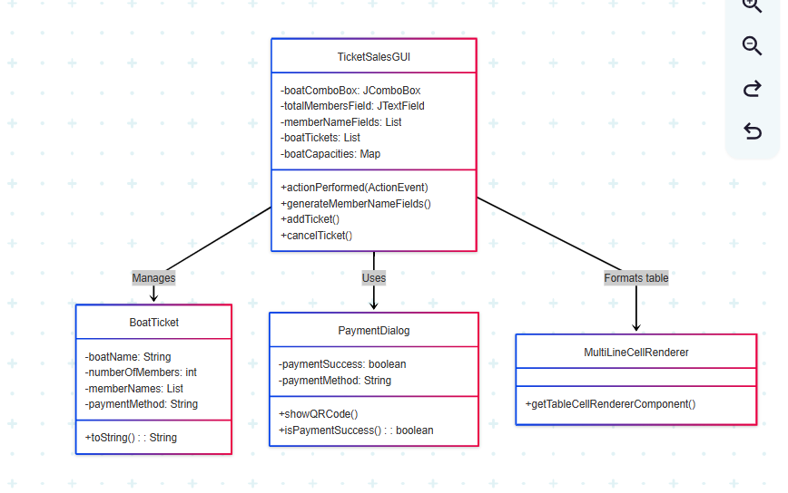

**MODULE DESCRIPTION**

**SCREEN-SHOTS**

|  |
| --- |
|  |

|  |
| --- |
|  |

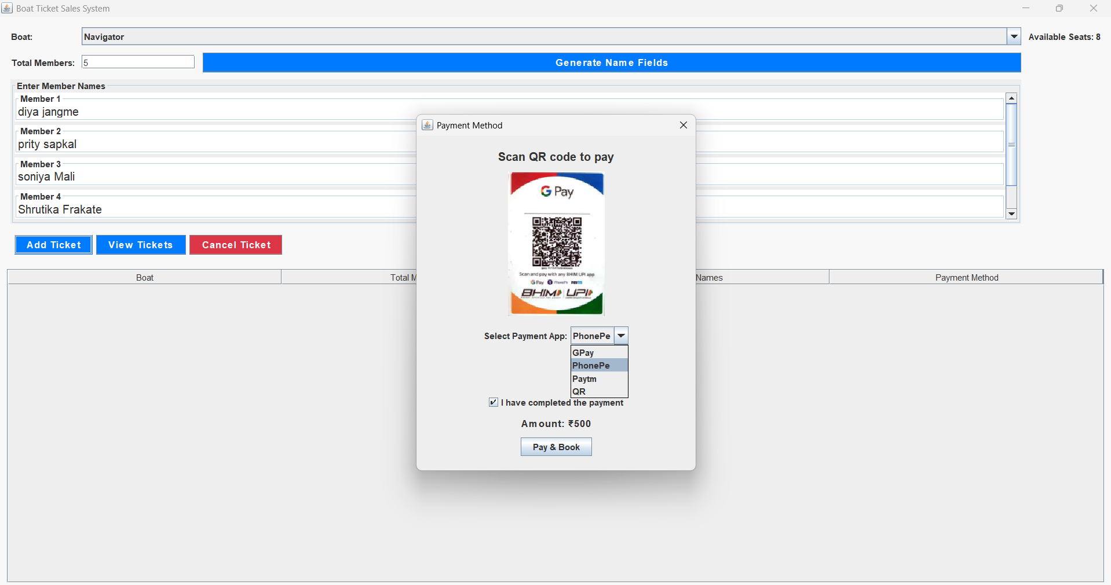

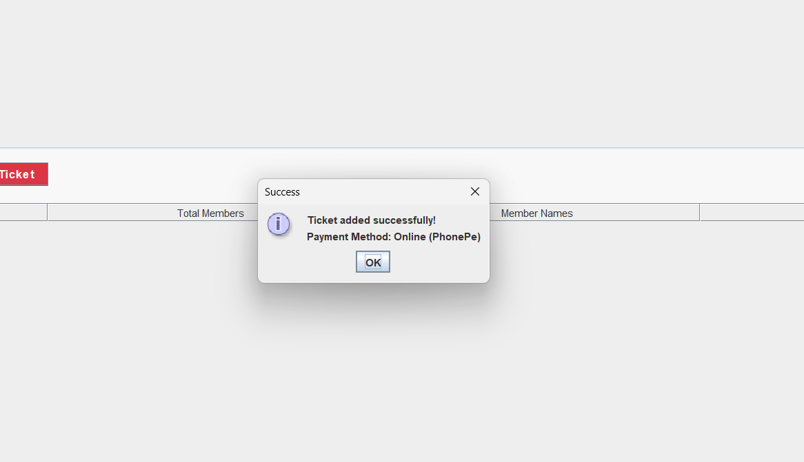

**GIT-HUB LINK**